**External Interfaces**

This section provides a detailed description of all inputs and outputs from the system. Additionally, a description of the hardware, software and communication interfaces used are provided.

**User Interfaces**

Upon first accessing the website, the user is greeted by the welcome page (Figure 1). From here, the system allows navigation to my.concordia.ca, the team Github page, as well as providing the user with the option to login.

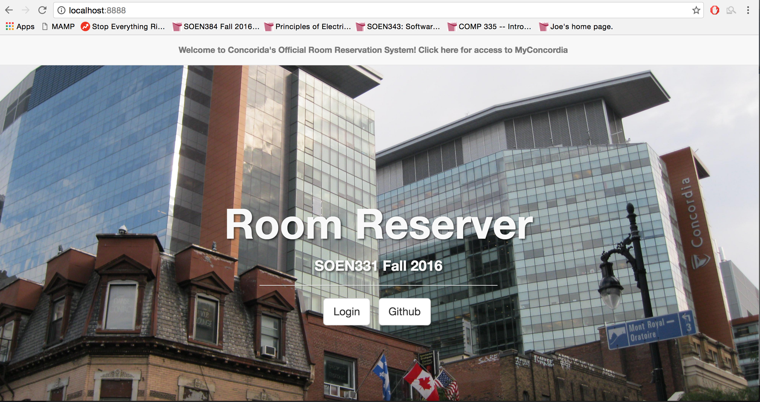

Once the user has selected the login feature, a pop-up is generated which accepts the user’s credentials, namely the student’s email and password (Figure 2). This login prompt also provides the option to change their password should the old one be forgotten (Figure 3). If the user’s information is invalid, they are notified as such and can attempt to fix their error.

Successfully logging in to the web application will redirect the user to the Reservation page, and can dictate the exact date they would like to see displayed. Upon selection, a table of times is generated for the user based on the day chosen, including all times currently booked by them, or other students who have used the system (Figure 4). Clicking a time slot that has already been taken would provide the user with the option to be placed on a waitlist, receiving a notification once the time slot has been freed and the place has been given to them (Figure 5). Should the time slot requested not already be booked, the user will be able to then edit the time they would like to book, and confirm their decision via a pop-up (Figure 6). The reservation allows provides the user with the opportunity to edit their student profile through an option in the upper navigation bar. Selecting this option will display a pop-up, upon which all-current user information will be displayed, thus allowing further editing (Figure 7).

**Hardware Interfaces**

The Hardware Interfaces of the system is summarized plainly by the machine being used to host both the web server and the database. This environment is formed of:

* I7-4790 3.6Ghz Processor
* Kingston 120G SSD
* WD 2TB HDD
* 16GB ram

**Software Interfaces**

* **Operating System**

The Operating System being used by the run-time environment is Windows 7 Professional, which includes Internet information Services (IIS), version 6.1 with PHP 7.0.9.

* **Web Server**

The website is being designed to run on Internet Information Server version 6.1, with PHP 7.0.9.

* **Database**

The website accesses a MySQL 5.6.26 MySQL Community Server (GPL) for the following features:

* + - Retrieving Student Information
    - Updating Student Information
    - Creating and Populating the central reservation table
    - Storing Student Reservation Times
    - Updating Waitlists for each available room
* **Libraries**

No external interfaces are to be used for this system with regards to frameworks, as object-relational structural and behavioral patterns are to be manually implemented. With regards to libraries, jQuery is being used to simplify front-end construction, as is Bootstrap (a front-end framework), though this does not compromise the requirements for an object-oriented system.

**Communication Interfaces**

* **Web Interface**

The entire reservation system is accessed over the Internet through a web site. As such, all communication between the various parts of the system is done through the web interface provided to the user, allowing their inputs to be translated to various events. This is all done through the use of HTTP protocol.